**Containership and Inheritance**

We can create an object of one class into another and that object will be a member of the class. This type of relationship between classes is known as **containership** or **has_a** relationship as one class contains the object of another class. And the class which contains the object and members of another class in this kind of relationship is called a **container class**.  
**The object that is part of another object is called contained object, whereas object that contains another object as its part or attribute is called container object.**

**Difference between containership and inheritance**

**Containership**  
-> When features of existing class are wanted inside your new class, but, not its interface  
for eg->  
1) computer system has a hard disk  
2) car has an Engine, chassis, steering and wheels.

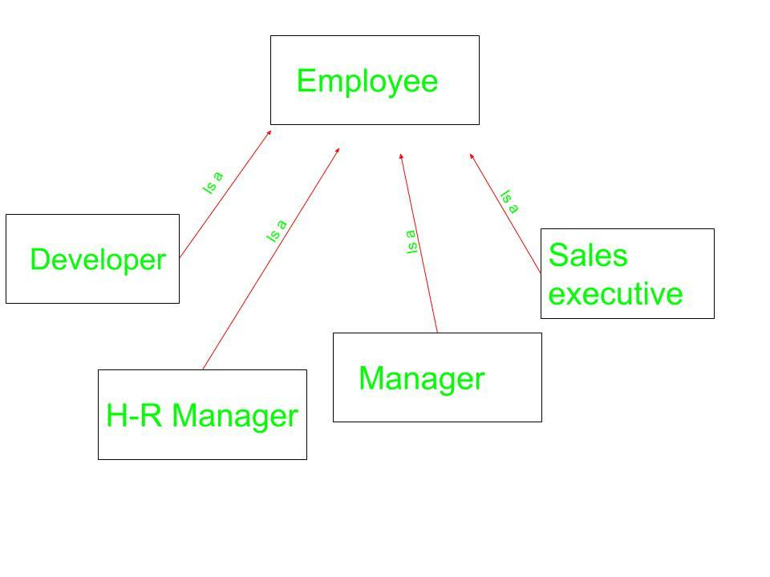**Inheritance**  
-> When you want to force the new type to be the same type as the base class.  
for eg->  
1) computer system is an electronic device  
2) Car is a vehicle

Employees can be of Different types as can be seen above. It can be a developer, an HR manager, a sales executive, and so on. Each one of them belongs to Different problem domain but the basic Characteristics of an employee are common to all.

**Syntax for Containership:**

// Class that is to be contained

class first {

.

.

};

// Container class

class second {

// creating object of first

first f;

.

.

};

Below examples explain the Containership in C++ in a better way.

**Example 1:**

|  |
| --- |
| // CPP program to illustrate  // concept of Containership    #include <iostream>  using namespace std;    class first {  public:      void showf()      {          cout << "Hello from first class\n";      }  };    // Container class  class second {      // creating object of first      first f;    public:      // constructor      second ()      {          // calling function of first class          f.showf();      }  };    int main ()  {      // creating object of second      second s;  } |

**Output:**

Hello from first class

**Explanation:** In the class **second,** we have an object of class **first**. This is another type of inheritance we are witnessing. This type of inheritance is known as **has_a** relationship as we say that class **second** has an object of first class **first** as its member. From the object f we call the function of class **first**.

**Example 2:**

|  |
| --- |
| #include <iostream>  using namespace std;    class first {  public:      first ()      {          cout << "Hello from first class\n";      }  };    // Container class  class second {      // creating object of first      first f;    public:      // constructor      second ()      {          cout << "Hello from second class\n";      }  };    int main ()  {      // creating object of second      second s;  } |

**Output:**

Hello from first class

Hello from second class

**Explanation:** In this program we have not inherited class **first** into class **second** but as we are having an object of class **first** as a member of class **second**. So, when default constructor of class **second** is called, due to presence of object **f** of **first** class in **second**, default constructor of class **first** is called first and then default constructor of class **second** is called.

**Example 3**

|  |
| --- |
| #include<iostream>  using namespace std;    class cDate  {      int mDay,mMonth,mYear;  public:      cDate()      {          mDay = 10;          mMonth = 11;          mYear = 1999;      }      cDate(int d,int m ,int y)      {          mDay = d;          mMonth = m;          mYear = y;      }      void display()      {          cout << "day" << mDay << endl;          cout <<"Month" << mMonth << endl;          cout << "Year" << mYear << endl;      }  };  // Container class  class cEmployee  {  protected:      int mId;      int mBasicSal;      // Contained Object      cDate mBdate;  public:      cEmployee()      {          mId = 1;          mBasicSal = 10000;          mBdate = cDate();      }      cEmployee(int, int, int, int, int);      void display();  };    cEmployee :: cEmployee(int i, int sal, int d, int m, int y)  {      mId = i;      mBasicSal = sal;      mBdate = cDate(d,m,y);  }  void cEmployee::display()  {      cout << "Id : " << mId << endl;      cout << "Salary :" <<mBasicSal << endl;      mBdate.display();  }    int main()  {      // Default constructor call      cEmployee e1;      e1.display();      // Parameterized constructor called      cEmployee e2(2,20000,11,11,1999);      e2.display();      return 0;  } |

**output**

Id : 1

Salary :10000

day 10

Month 11

Year 1999

Id : 2

Salary :20000

day 11

Month 11

Year 1999